**Part 1. SQL DDL (36 points)**

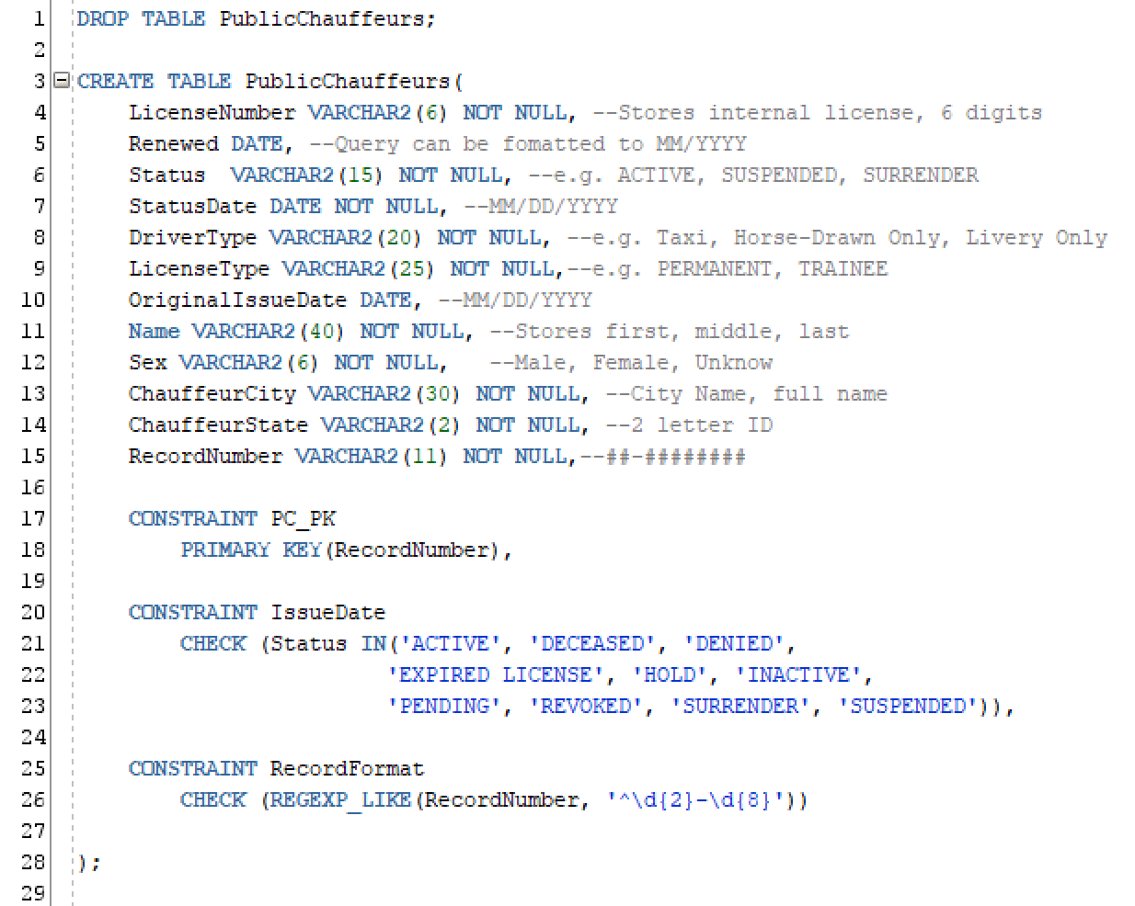

**Part 2. SQLDML (64 points)**

A. SELECT AName FROM Animal WHERE TIMETOFEED < 2;

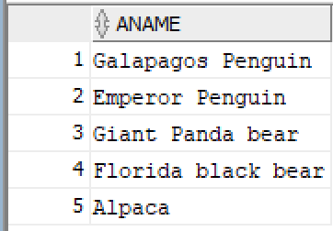

B. SELECT AName, TIMETOFEED FROM Animal WHERE ACategory = 'rare' ORDER BY TIMETOFEED;

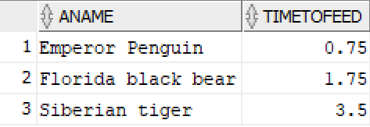

C. SELECT AName, ACategory FROM Animal WHERE AName LIKE '%bear%';

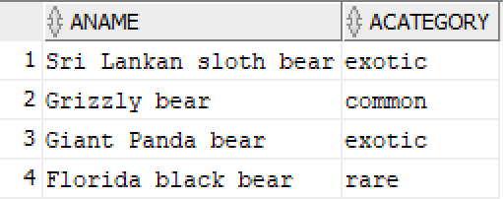

D. SELECT AName, ACategory FROM Animal WHERE ACategory IS NULL;

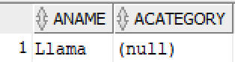

E. SELECT DISTINCT ACategory FROM Animal WHERE TIMETOFEED <= 2.2 AND TIMETOFEED > 1;

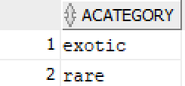

F. SELECT AName FROM Animal WHERE AName LIKE '%tiger%' AND ACategory != 'common';

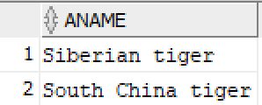

G. SELECT MIN(TIMETOFEED), MAX(TIMETOFEED) FROM Animal;

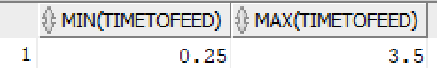

H. SELECT AVG(TIMETOFEED) FROM Animal;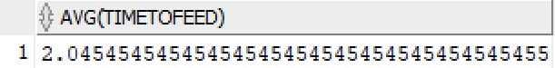

EC1. SELECT * FROM Animal WHERE TIMETOFEED = (SELECT MAX(TIMETOFEED) FROM Animal);’

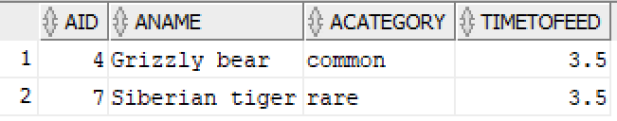

EC2. SELECT * FROM Animal WHERE TIMETOFEED <= (SELECT AVG(TIMETOFEED) * 1.25 FROM Animal) ORDER BY TIMETOFEED;

